FOR IMMEDIATE RELEASE
March 2026

MassCTE Hosts 93rd Annual Conference Highlighting Innovation, Excellence, and Student Achievement in Career & Technical Education
The Massachusetts Career & Technical Educators Organization (MassCTE) proudly hosted its 93rd Annual Leadership Conference, Workshop, and Awards Banquet on March 27–28, 2026, bringing together educators, administrators, industry leaders, and students from across the Commonwealth.
Held under the theme “Tools for Teaching: Empowering CTE Teachers for the Future,” the conference focused on strengthening instructional practices, fostering innovation, and preparing students for success in a rapidly evolving workforce.
The two-day event featured leadership sessions, keynote presentations, and breakout workshops addressing topics such as artificial intelligence in education, performance-based assessment, literacy in vocational settings, and competency-based grading. Attendees also connected with industry partners through exhibitor sessions and networking opportunities designed to strengthen the link between education and workforce needs.

Recognizing Excellence Across Massachusetts
A highlight of the conference was the Annual Awards Banquet, which honored outstanding students, educators, and community leaders who have made significant contributions to Career & Technical Education.
Among the distinguished honorees:
- Kristen Martinson, Worcester Technical High School – New CTE Teacher of the Year
- Kevin Holmes, President & CEO of Advantage Truck Group – Friend of Career & Technical Education
- State Representative Adam J. Scanlon – Harold L. Pride Award
- Timothy P. Murray, President & CEO of the Worcester Regional Chamber of Commerce – Presidential Leadership Award
Student award recipients from across Massachusetts were also recognized for excellence in both secondary and postsecondary programs. The conference booklet identifies honorees from Bay Path Regional Vocational Technical School, Shawsheen Valley Technical High School, Southeastern Regional Vocational Technical School, Smith Vocational and Agricultural School, Blackstone Valley Regional Voc Tech High School, Southeastern Technical Institute, and Whittier Regional Vocational Technical District.

Student Innovation and Craftsmanship Take Center Stage
A defining feature of this year’s conference was the student project showcase and raffle, which highlighted creativity, technical expertise, and collaboration.

Best In Show
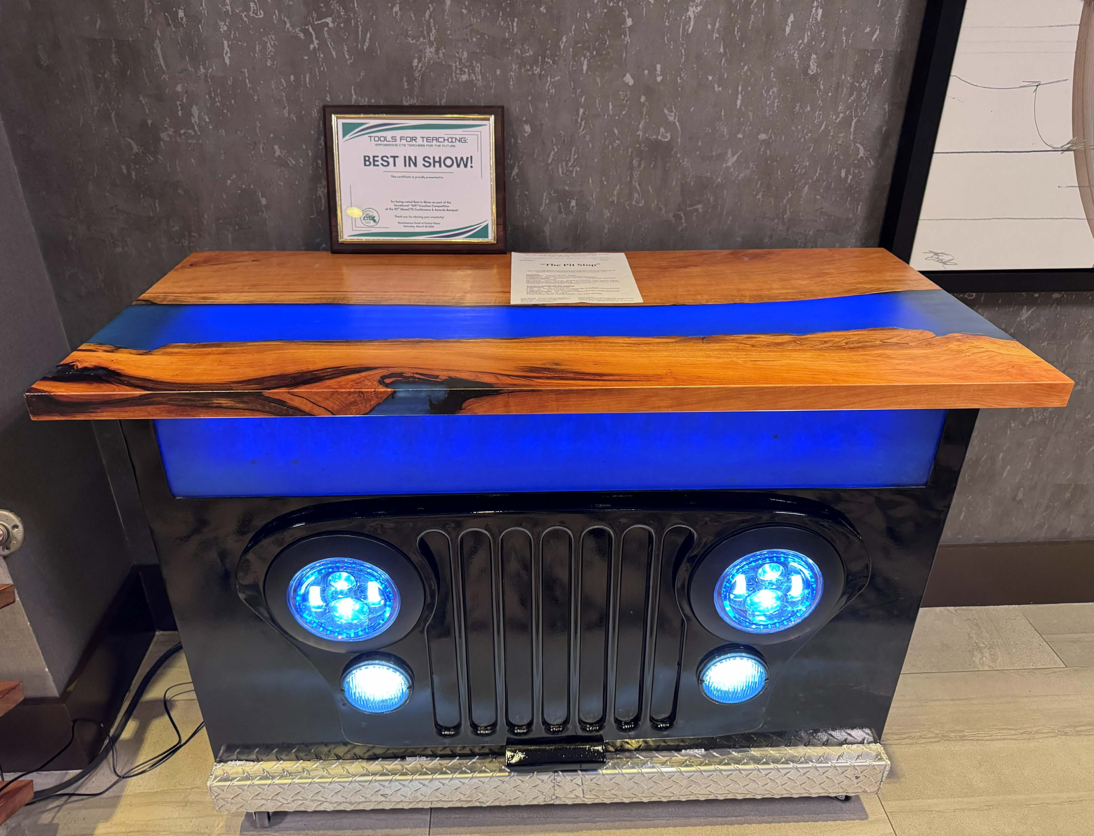
The Best in Show award was presented to “The Pit Stop,” an automotive-inspired, interdisciplinary project created by students at Southeastern Regional Vocational Technical High School. The piece brought together work from automotive, carpentry, collision repair, electrical, and metal fabrication and welding programs.

Most Creative
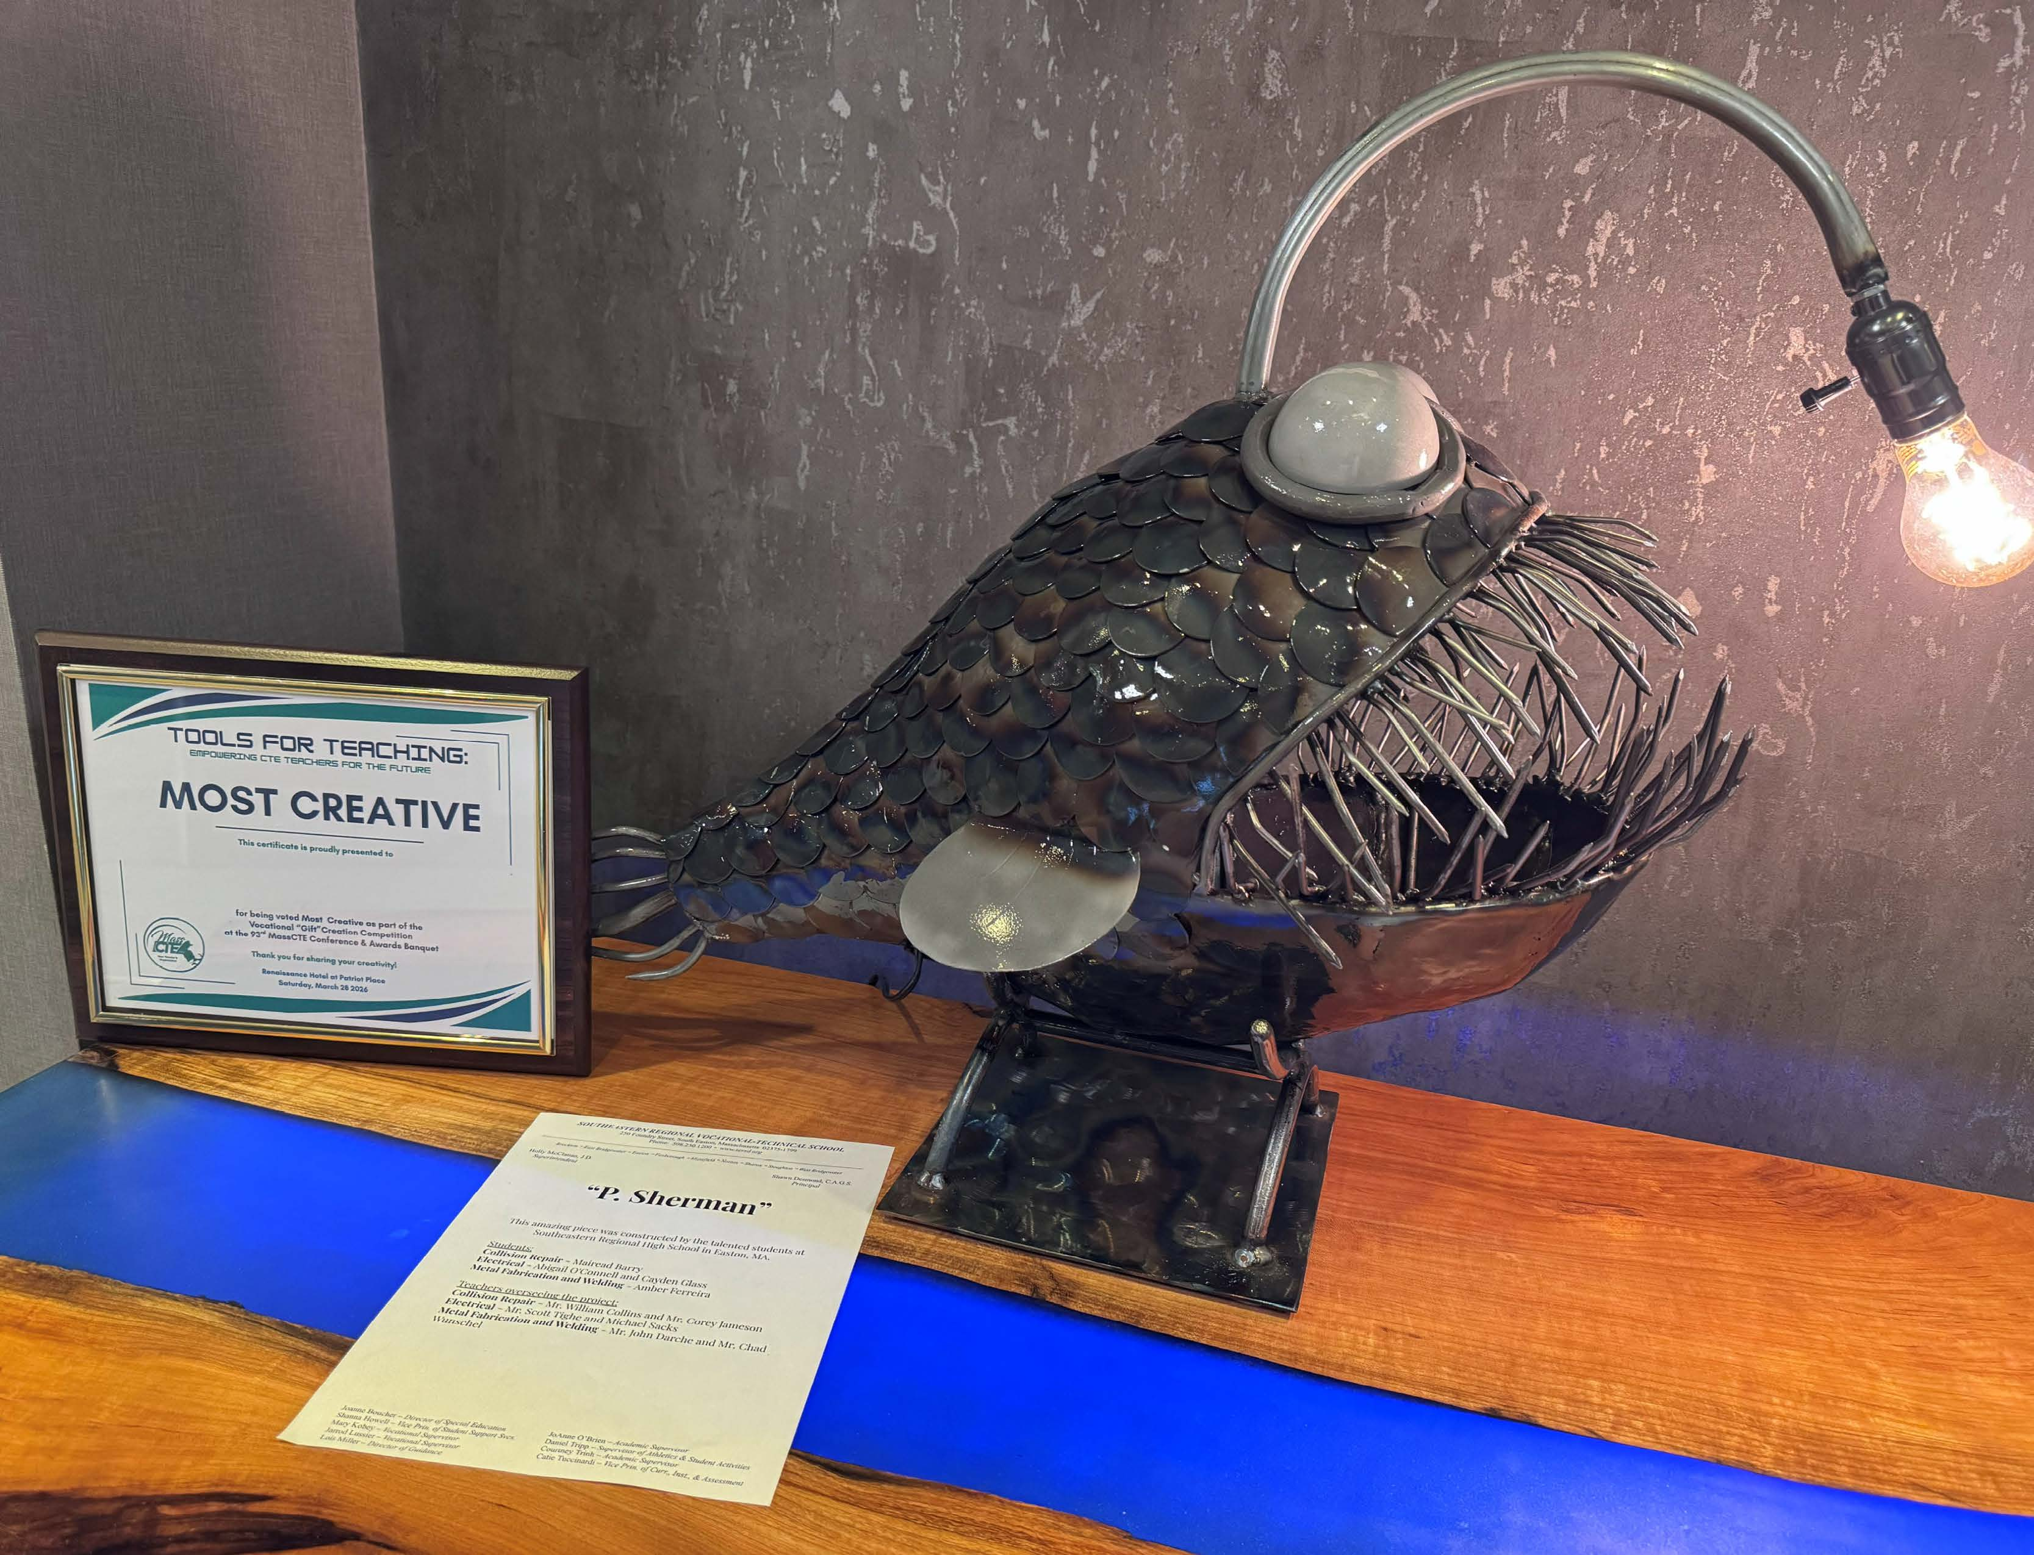
The Most Creative Award was presented to “P. Sherman,” a striking illuminated sculpture created by students at Southeastern Regional Vocational Technical High School through collaboration among collision repair, electrical, and metal fabrication and welding programs.
Together, these projects demonstrated the creativity, craftsmanship, and cross-disciplinary teamwork that define high-quality Career & Technical Education.

Leadership Perspective
“This year’s conference truly reflected the strength and future of Career & Technical Education in Massachusetts,” said Brian Cummings, Executive Director of MassCTE. “From innovative classroom practices to the incredible craftsmanship demonstrated in student projects like The Pit Stop and P. Sherman, we are seeing firsthand how CTE prepares students with the skills, creativity, and confidence needed to succeed in today’s workforce.”
He added, “Equally important is the collaboration among educators, industry partners, and students. This conference continues to be a vital space where those connections are strengthened and where the future of our workforce is shaped.”

Advancing Teaching and Learning
Conference sessions emphasized practical strategies educators can apply immediately, including strengthening instructional fundamentals, integrating emerging technologies such as AI, designing authentic assessments, and supporting student success in vocational settings. Sessions also focused on leadership development and sustainable instructional quality.

Strengthening the Future Workforce
MassCTE’s annual conference remains a cornerstone event for advancing Career & Technical Education across the Commonwealth, ensuring students are prepared for high-demand careers and future opportunities.
MassCTE extends its sincere appreciation to the conference committee, presenters, exhibitors, and participants who made this year’s event a success. The booklet also recognizes the conference committee, exhibitors, and executive board members who supported the event.

About MassCTE
The Massachusetts Career & Technical Educators Organization (MassCTE) supports educators, promotes excellence in Career & Technical Education, and strengthens connections between education and industry across Massachusetts.

